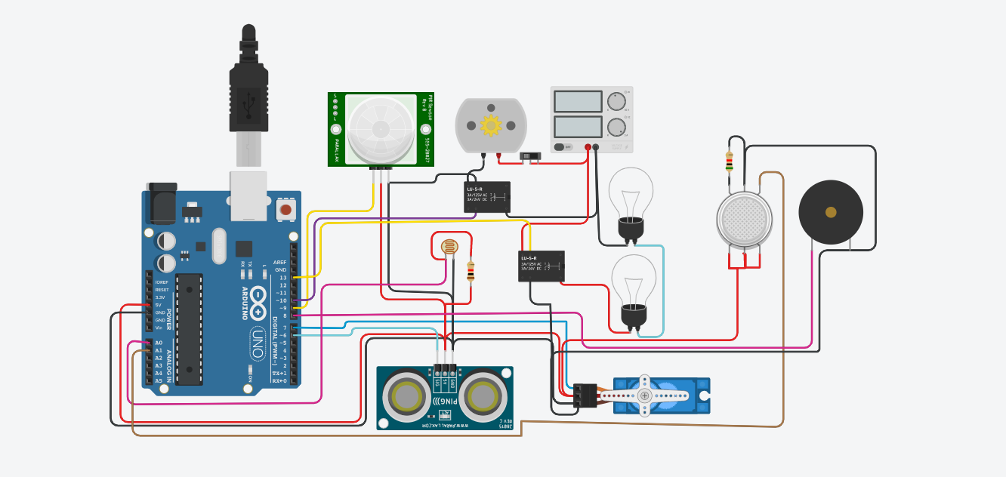

Smart home automation using sensors

The sensors connected to the microcontroller board are smoke,detector,PIR,ultrasonic and LDR sensor. Somke detector is used to sense the gas if it leakage. The data sensed by the sensors are then if gas is leaked the alarm circuit is active. The ultrasonicls used for automatic open the front door if some someone is in front of the door. The PIR is used for detection of human and turn ON the fan. Also the fan is controlled by manually. LDR is used for automatics light controlin home if someone is in home at night the bulb is automatically turned ON and at dey time it automatically turned OFF.

Things that you need

1. Ardunio
2. Smoke detector mq6
3. Pir
4. Ldr
5. Ultrasonic
6. Dc power source (any 12v)
7. Relay board of 2 channel

